1. Process vs Thread
2. Process Based Server side web technologies vs Thread Based Server side web Technologies.

**1.Process vs Thread:-**

a. process can be with or with out threads.

b. Thread is part of process.So it is called as light weight sub process or light weight process.

c. Thread is sub task with in main task.

d. process is heavy weight.

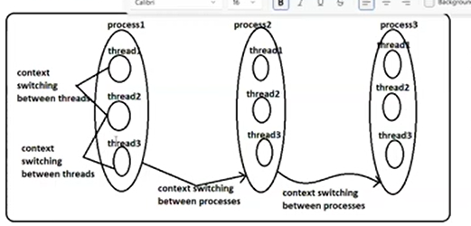

When we start java app, one process will be created. In the process, two default threads will be created .

1. Main thread.
2. Garbage collector.

**Context Swithcing/control switching:-** The process of transferring the control from one process to another process / from one thread to another thread is technically called as Context switching.

This is quite common when single cpu executes multiple processes or multiple threads simultaneously.

Processes are heavy weight, so they take the more time to context switching.

Threads are low weight and run in process, so they take less time to context switching.

**2.Server side Technologies**:-

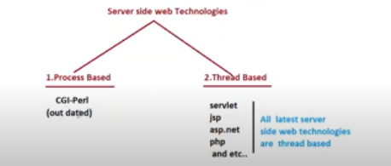

CGI-Common Gate way

PERL- Practical Extraction Reporting Language.

Drawback in process Based:- If we give multiple requests to perl-component, related web container will create the multiple processes and each process represent the one request.

More time is wasted for context switching.

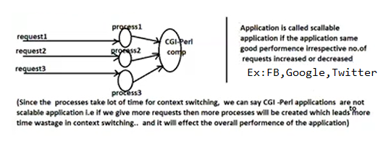

If we give multiple requests to thread based web server for web components, related web container will creates multiple threads with in same process. Each thread represents the one request.

